**Replication controller & Replicaset & Deployments in Kubernetes:**

* These all are used to create the specified no. of pods ,running the pods and deploy the application on pod at all times in Kubernetes cluster.
* We have to specify the replicas inside a yml file how many we want.All are having self healing feature.
* But there are some diffrences these are
* We can specify the match lables inside a replicaset yml file but we can’t specify it in a RC yml file.
* RC and RS are not provide the rollback and rolling update feature whereas deployment will provide the **roll back & rolling update** feature.
* **Roll back** means if new version of application is not working properly or not satisfied with client we can deploy previous version of application in deployments.

**Steps to create the RC,RS and Deployment:**

* First crate ec2 instance and update the server.
* Install the docker,kubectl,kops on that server. Configure the aws cli by using **aws configure** command.
* Create the cluster by using the kops command and update the cluster by using command .
* Create the RC yml file and create the rc y using **kubectl create -f filename** command.

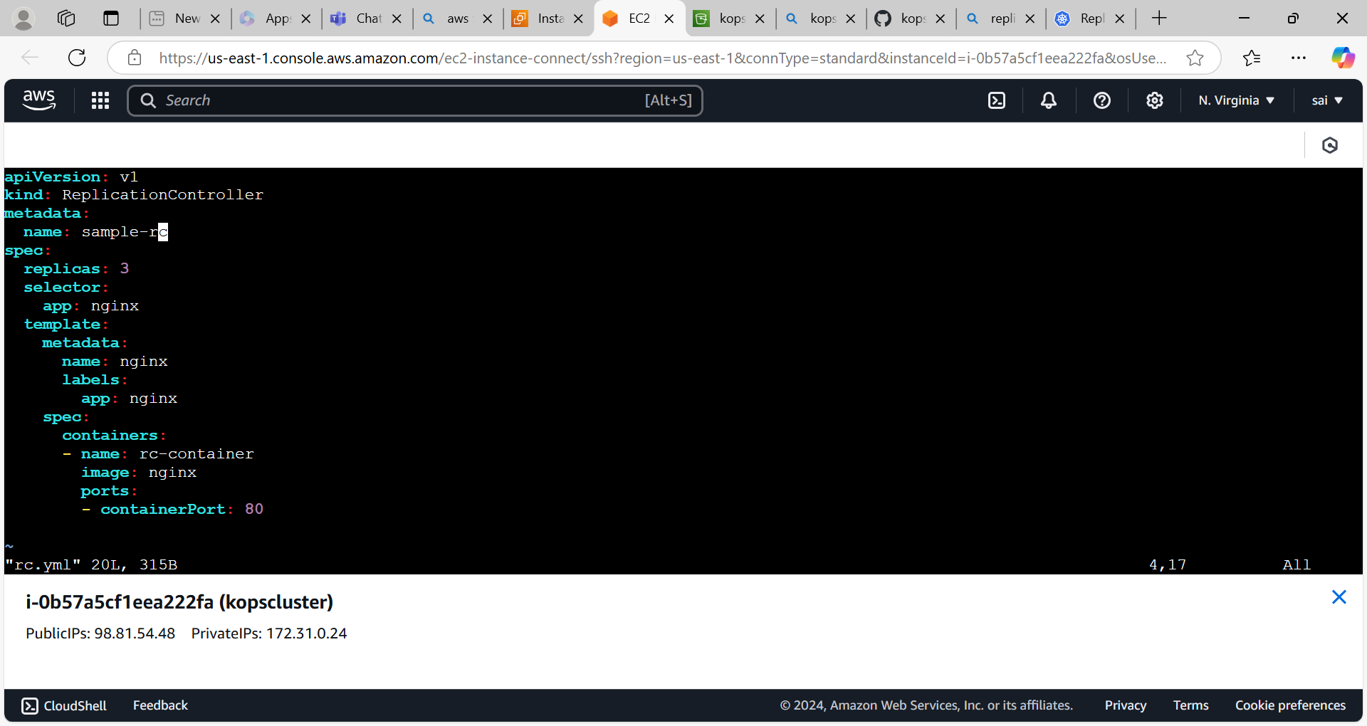

* Create the rc and pods

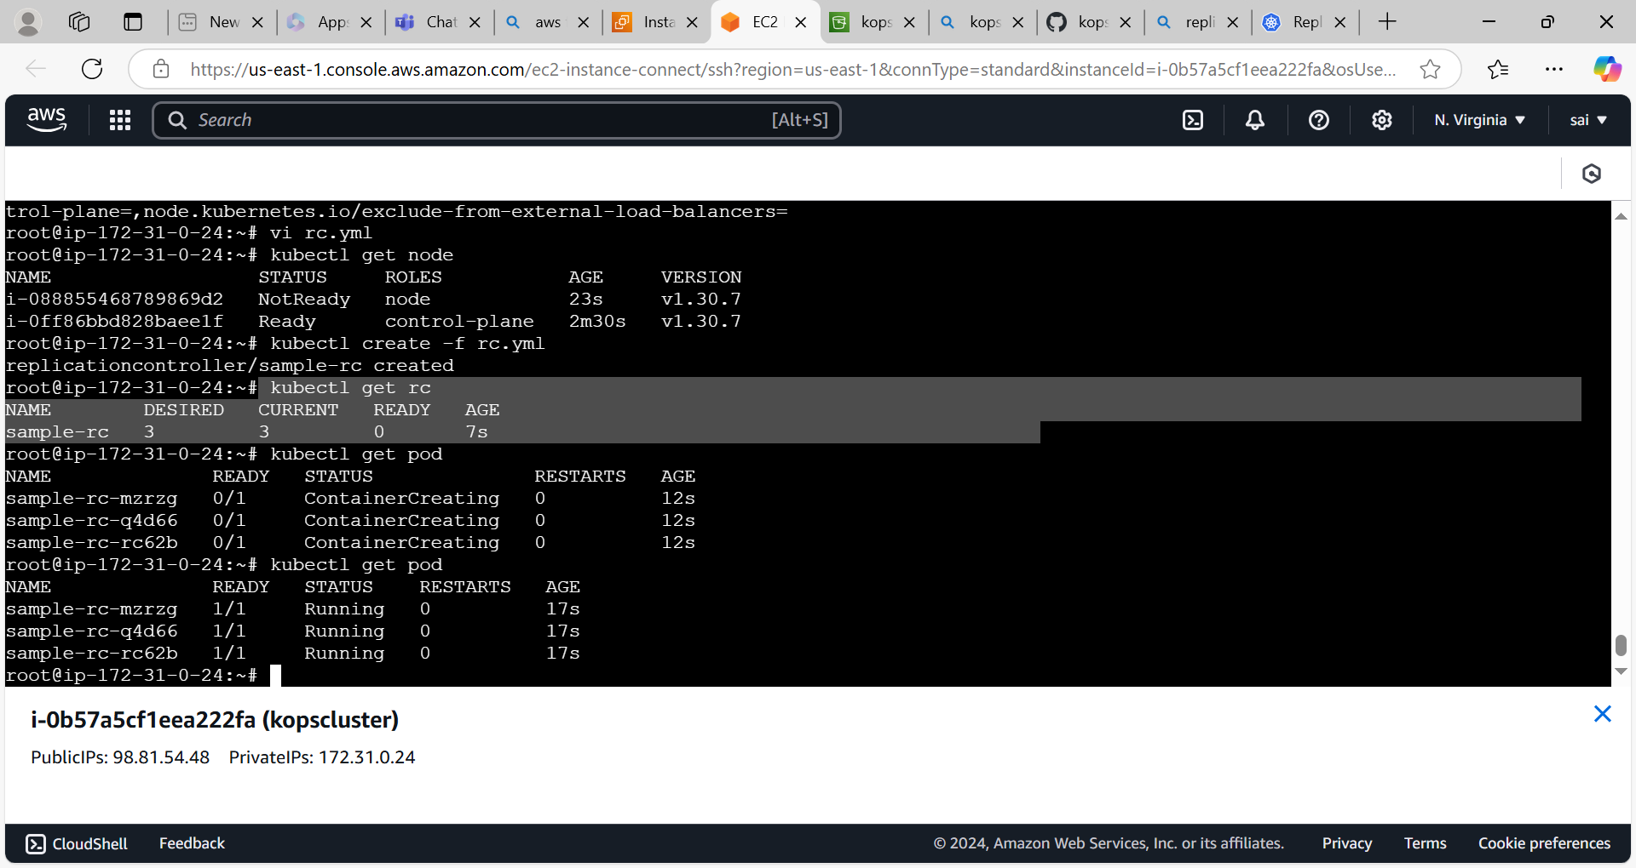

* Create the nodeport service to access the application externally.
* Create service yml file.

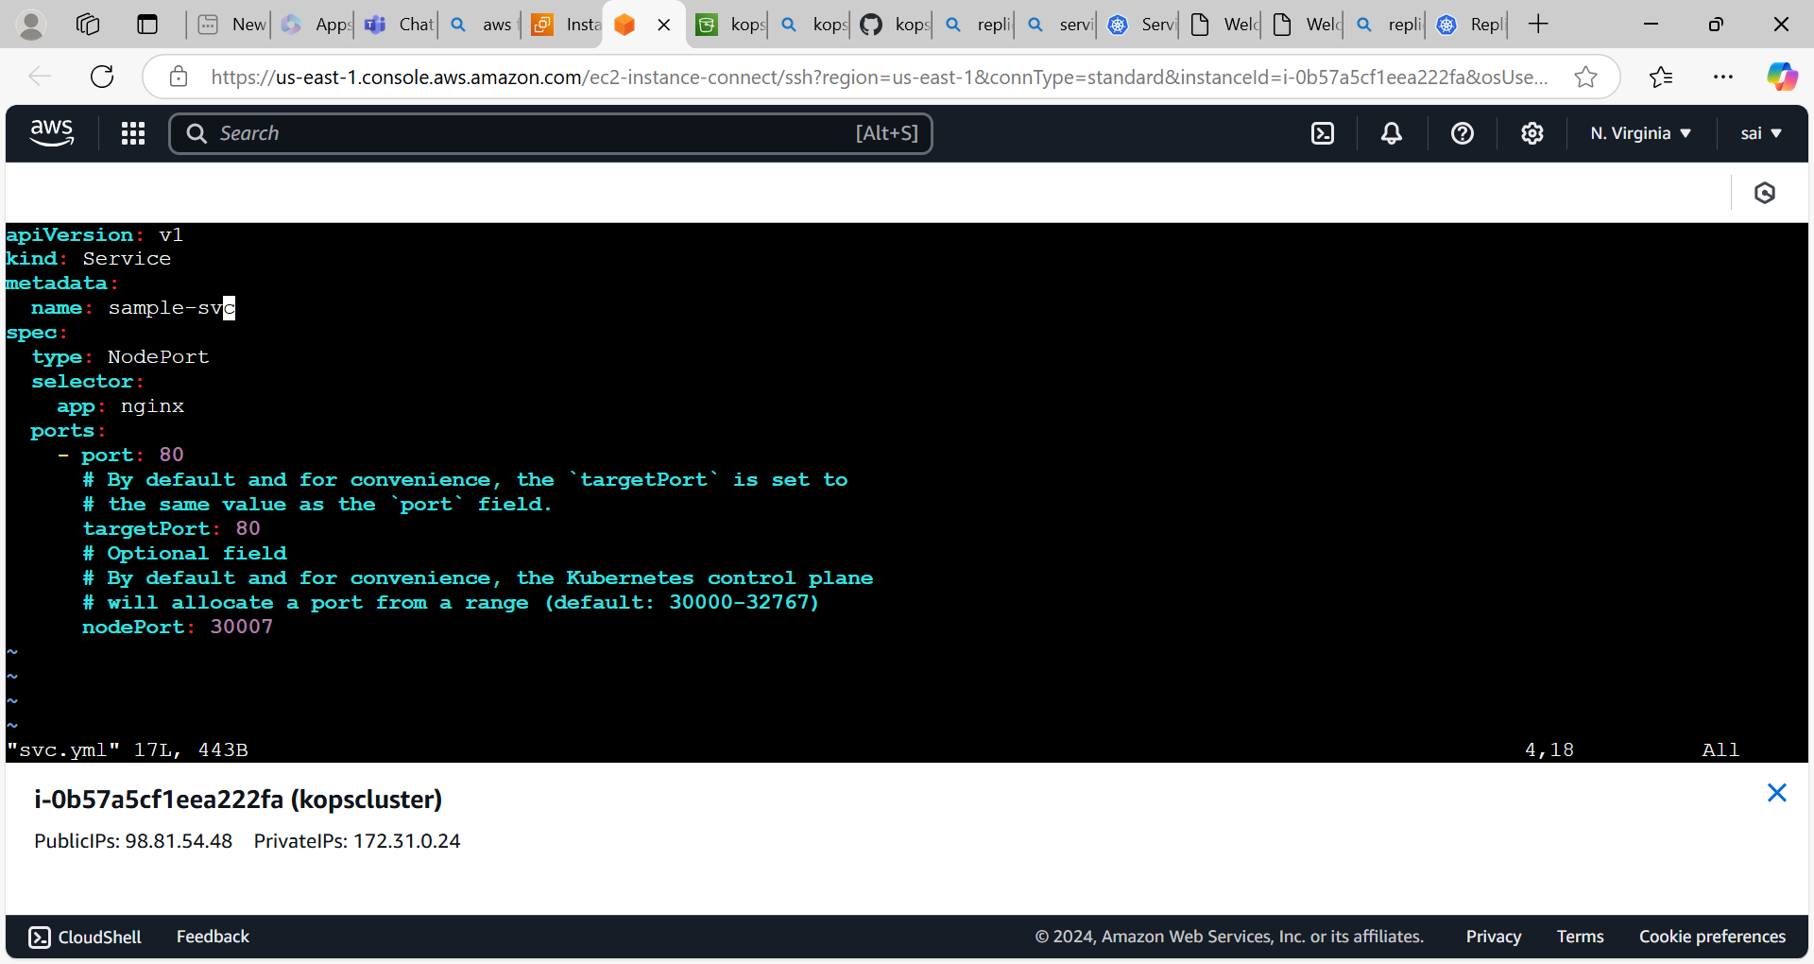

* Creation of nodeport svc

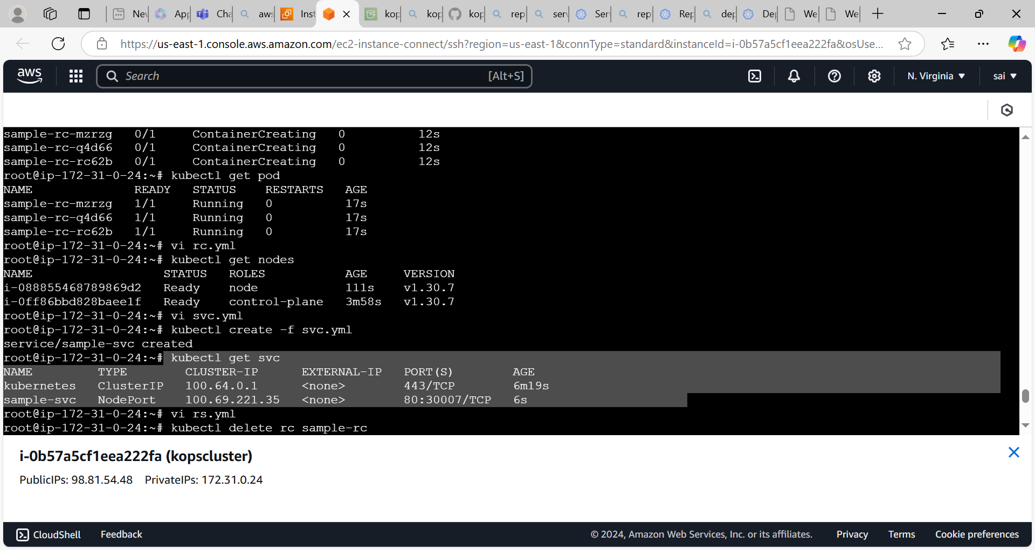

* Now access the nginx application by using nodeip with nodeport from the browser.

Access the nginx with control-plane server

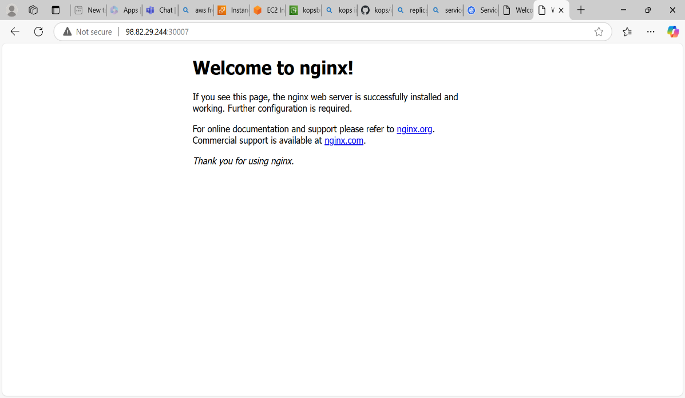

Access the nginx from worker node

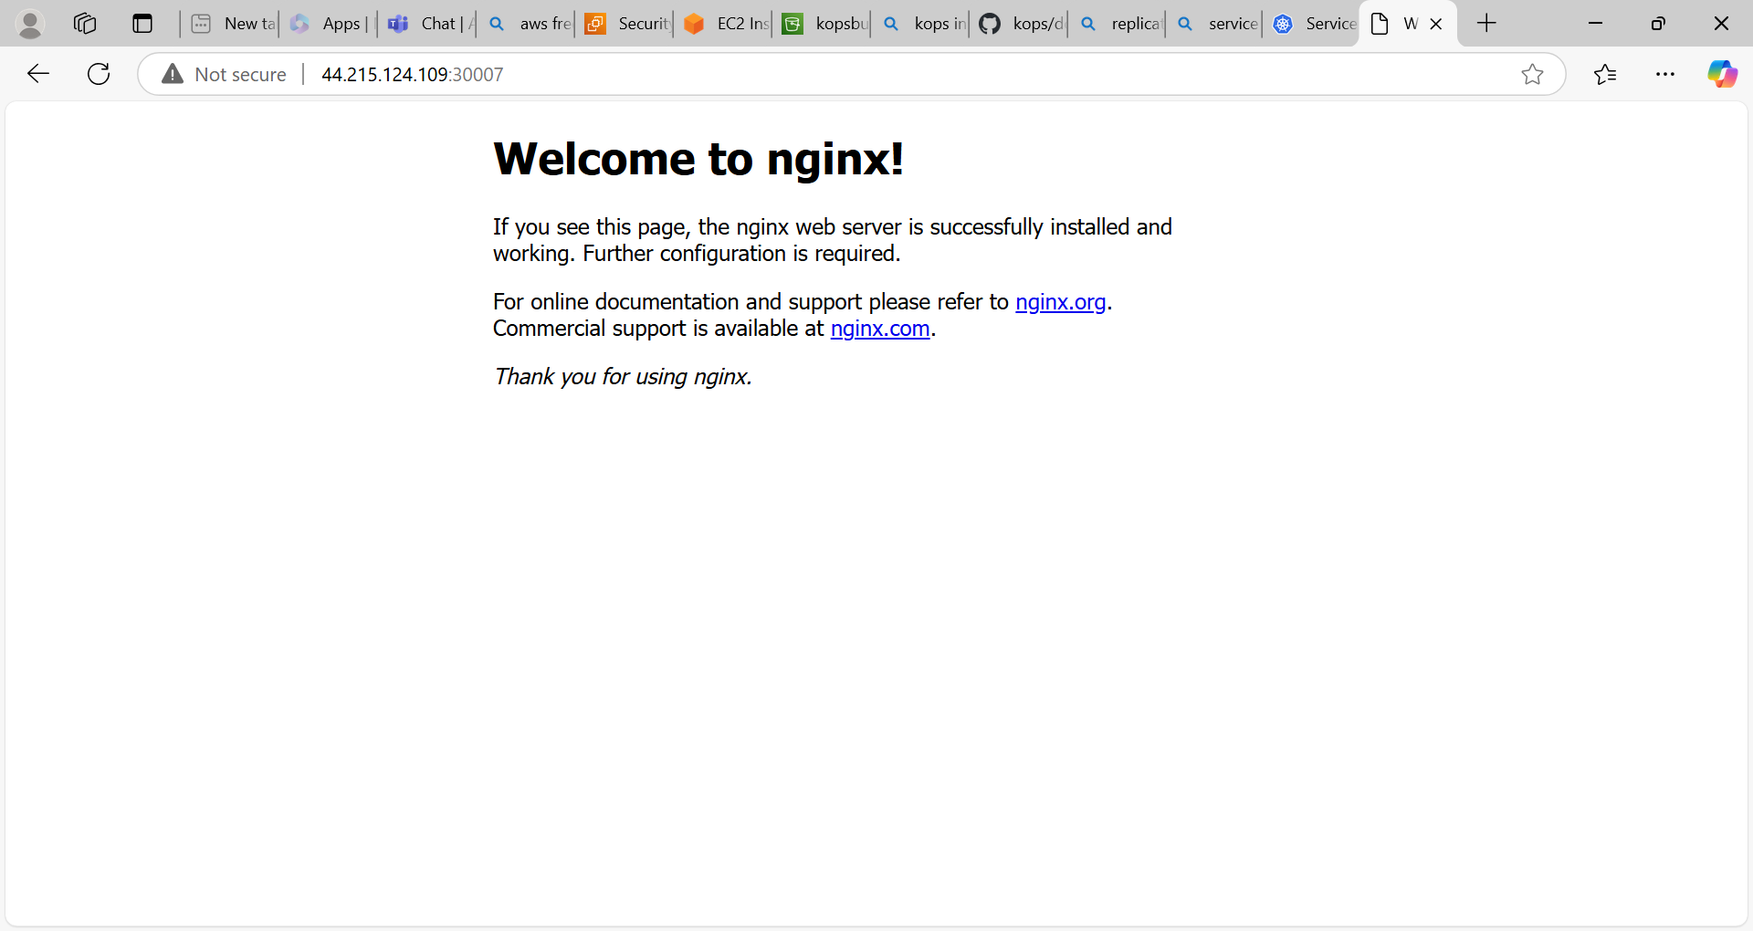

* Create the Replicaset yml file and create the rs and create nodeport service yml file like a replication controller.

RS yml file

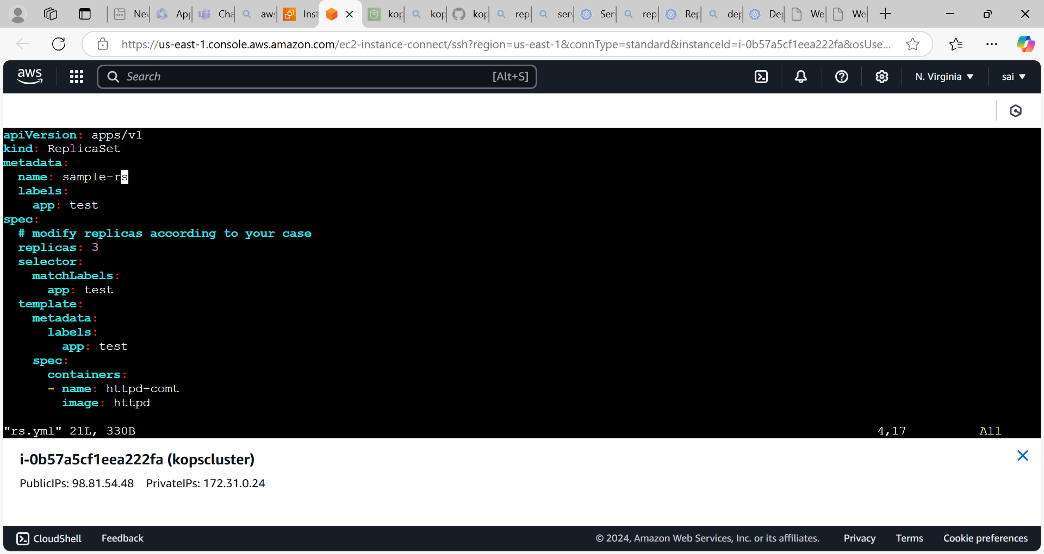

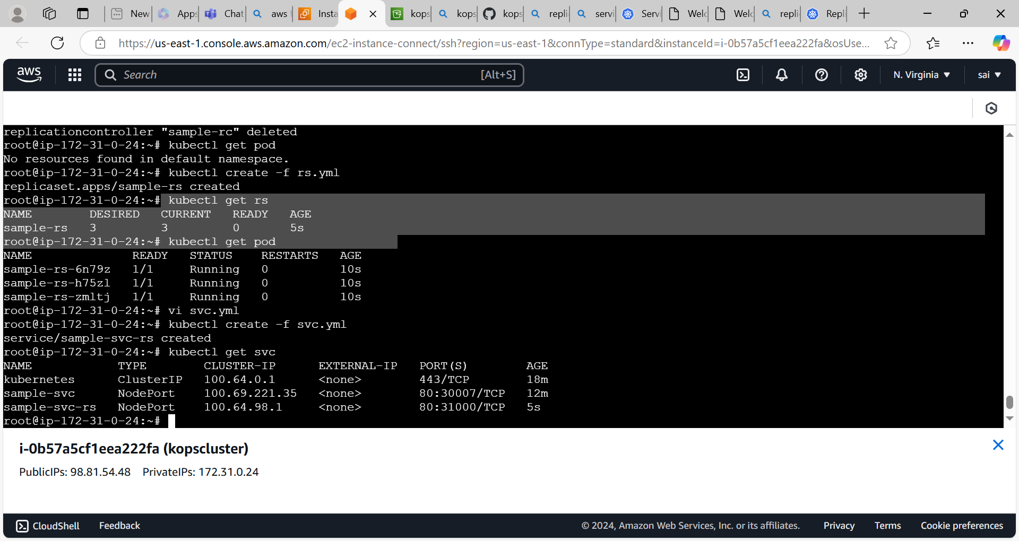

* Access the httpd applicaton from externally

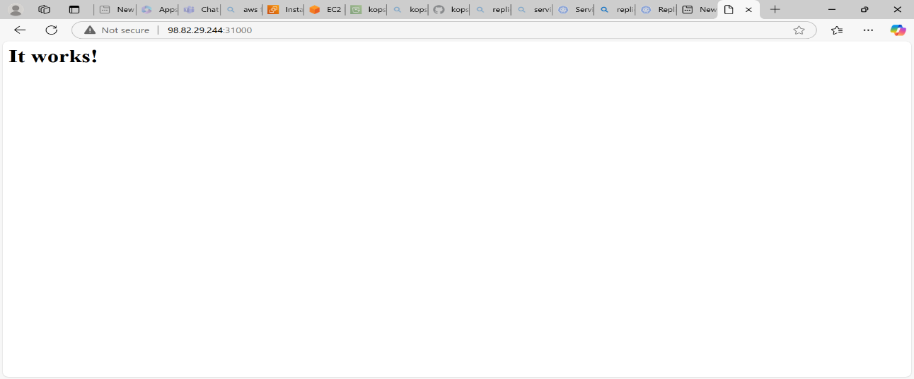

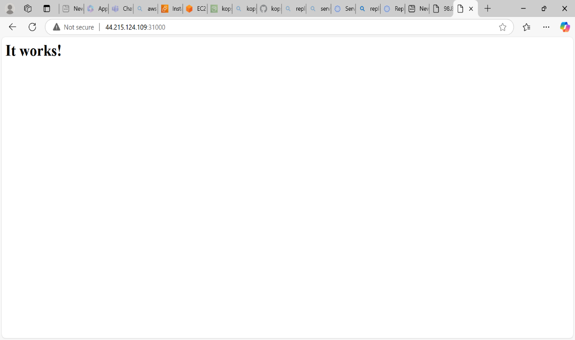

* Create the deployment yml file and nodeport svc yml file.

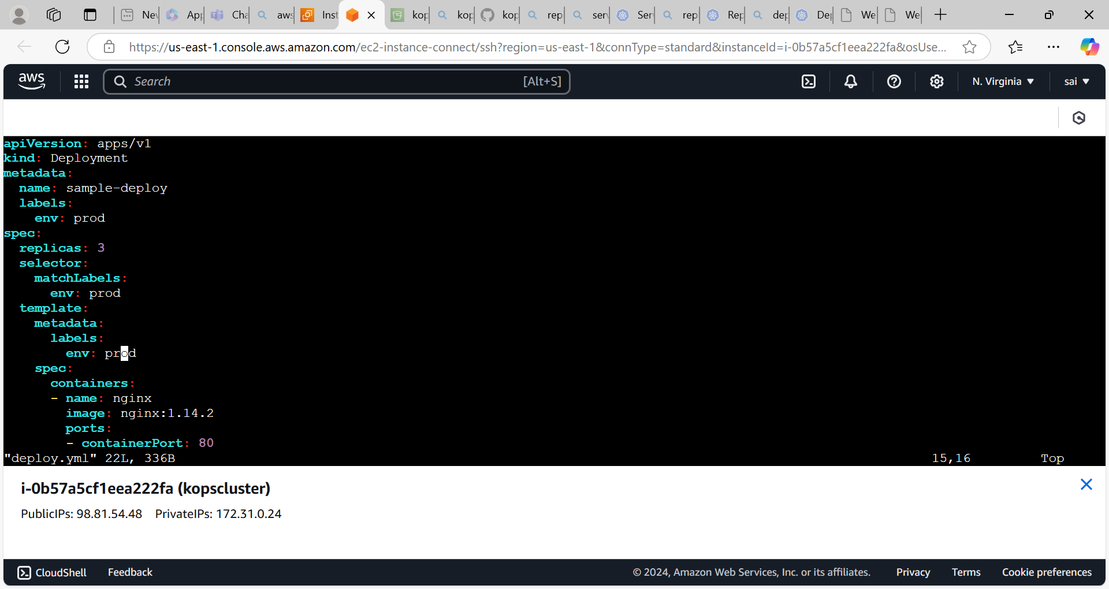

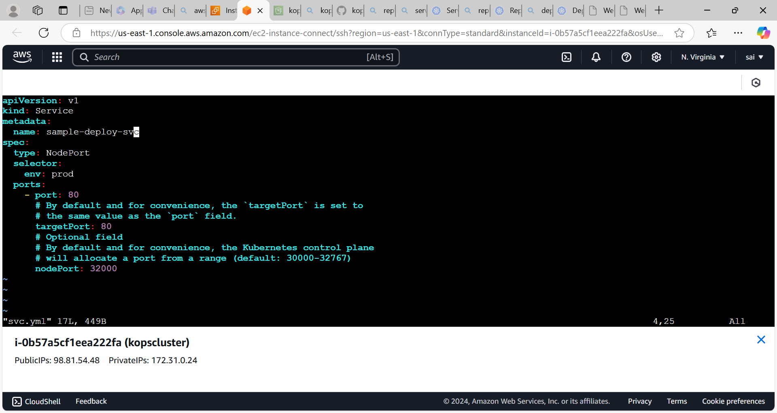

Access the nginx app

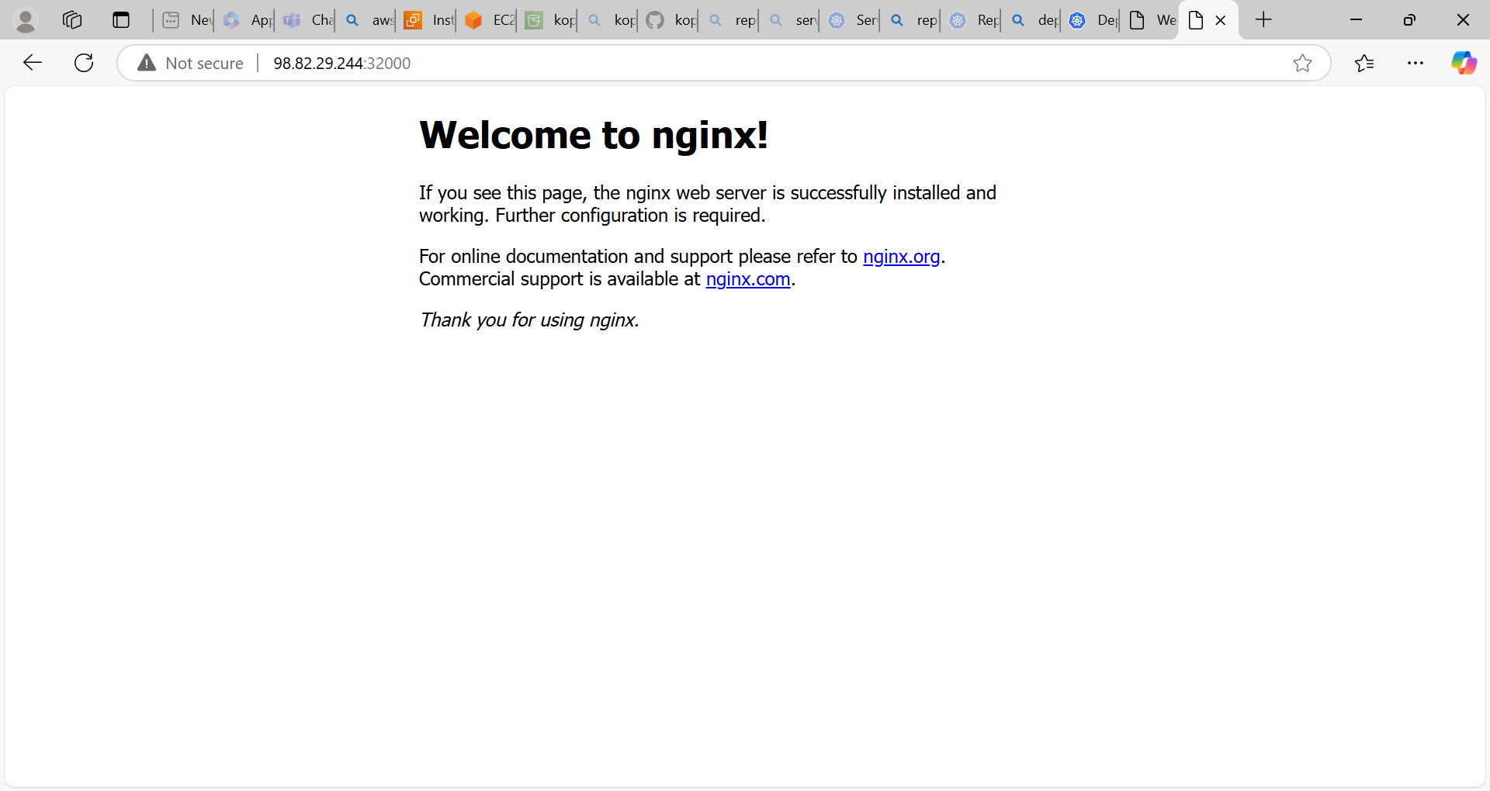

* We can roll out and roll back the application by using below command in deployments.

**Kubectl set image deploy/deployment name containername=imagename**(on which image we want to update) command

* Here we can update the nginx image to httpd image

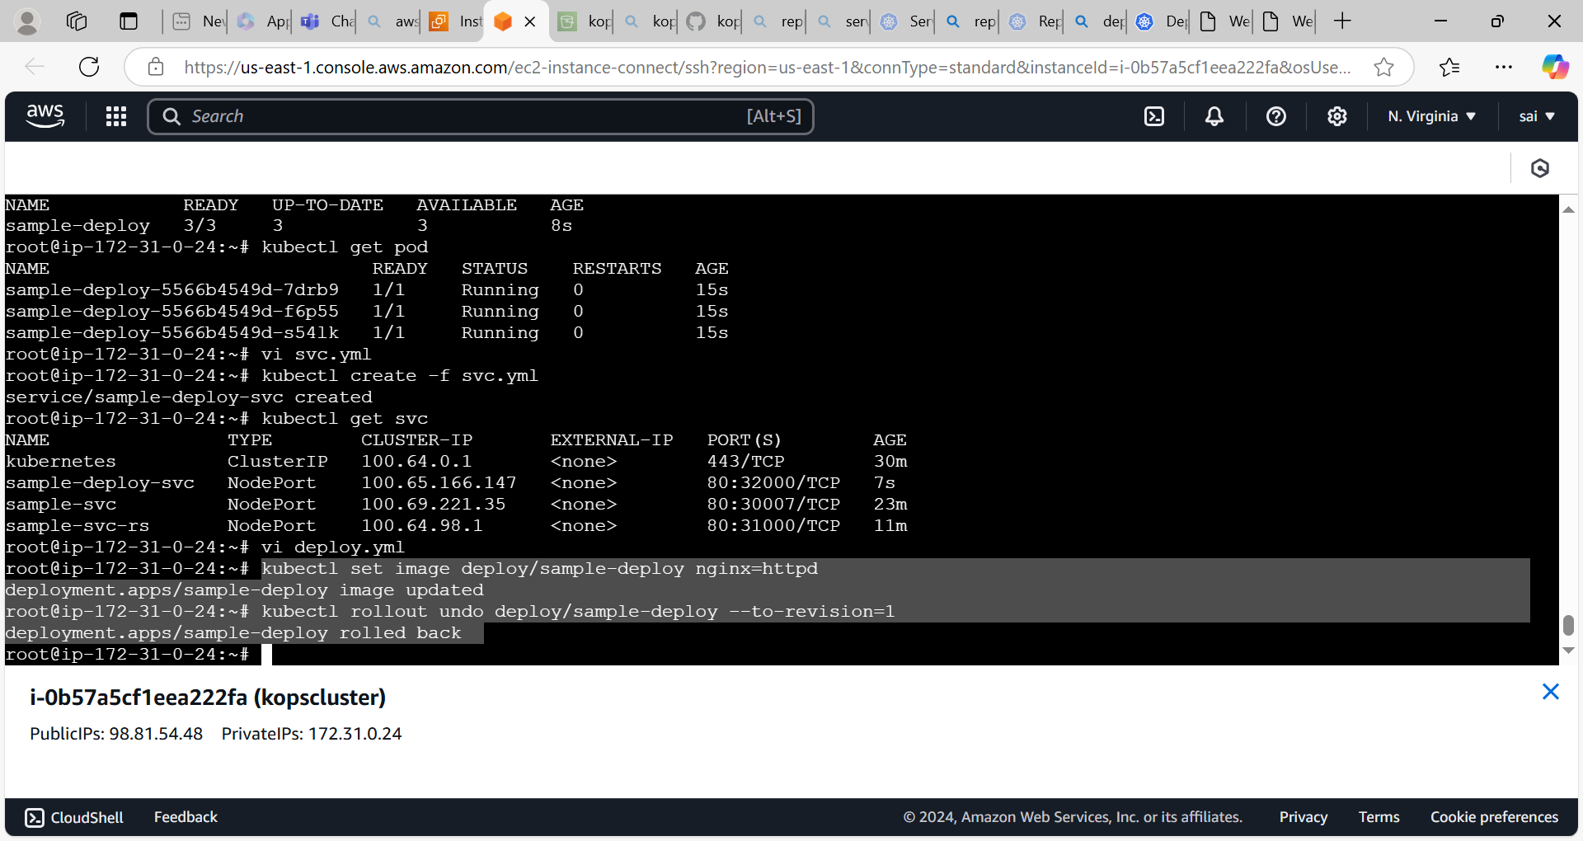

We can acces the httpd application after rolling update

